Develop a VB Project to display all picture files in our system

Formdesign:

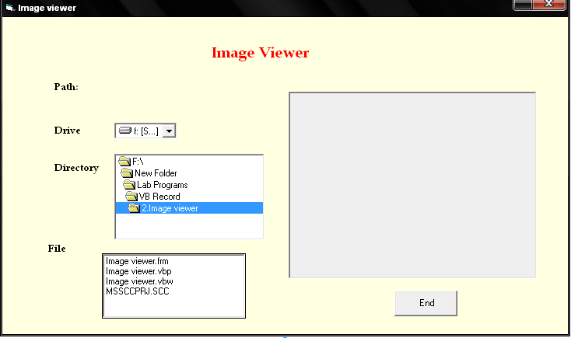

Properties:

Control | Name | Caption
Drivelistbox | Drive1
Dirlistbox | Dir1
Filelistbox | File1
Picturebox | Picture1
Command1 | Cmdclose | End
Label3 | lblpath

2.Image Viewer
Aim:
Develop a VB Project to display all picture files in our system

Coding:
Private Sub cmdclose_Click()
End
End Sub

Private Sub Dir1_Change()
File1.Path = Dir1.Path
End Sub

Private Sub Drive1_Change()
Dir1.Path = Drive1.Drive
End Sub
Private Sub File1_Click()
If Mid$(File1.Path, Len(File1.Path), i) = "\" Then
s = File1.Path & File1.FileName
Else
s = File1.Path & "\" & File1.FileName
End If
Lblpath.Caption = s
Picture1.Picture = LoadPicture(s)
End Sub

Private Sub Form_Load()
File1.Pattern = "*.jpg;*.ico;*.bmp;*.gif"
End Sub

Output:
